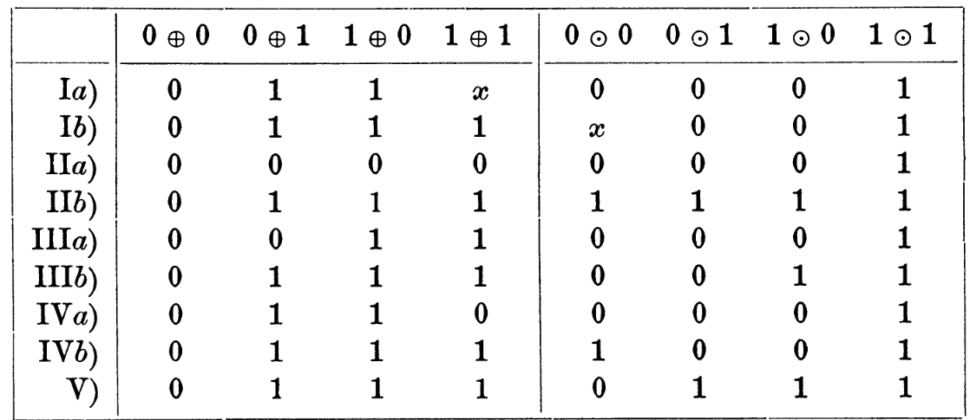

I.a) 0 + 0 = 0; 0 + 1 = 1; 1 + 0 = 1; 1 + 1 = x; 0 * 0 = 0; 0 * 1 = 0; 1 * 0 = 1; 1 * 1 = 1;
I.b) 0 + 0 = 0; 0 + 1 = 1; 1 + 0 = 1; 1 + 1 = 1; 0 * 0 = x; 0 * 1 = 0; 1 * 0 = 0; 1 * 1 = 1;
II.a) 0 + 0 = 0; 0 + 1 = 0; 1 + 0 = 0; 1 + 1 = 0; 0 * 0 = 0; 0 * 1 = 0; 1 * 0 = 0; 1 * 1 = 1;
II.b) 0 + 0 = 0; 0 + 1 = 1; 1 + 0 = 1; 1 + 1 = 1; 0 * 0 = 1; 0 * 1 = 1; 1 * 0 = 1; 1 * 1 = 1;
III.a) 0 + 0 = 0; 0 + 1 = 0; 1 + 0 = 1; 1 + 1 = 1; 0 * 0 = 0; 0 * 1 = 0; 1 * 0 = 0; 1 * 1 = 1;
III.b) 0 + 0 = 0; 0 + 1 = 1; 1 + 0 = 1; 1 + 1 = 1; 0 * 0 = 1; 0 * 1 = 0; 1 * 0 = 1; 1 * 1 = 1;
IV.a) 0 + 0 = 0; 0 + 1 = 1; 1 + 0 = 1; 1 + 1 = 0; 0 * 0 = 0; 0 * 1 = 0; 1 * 0 = 0; 1 * 1 = 1;
IV.b) 0 + 0 = 0; 0 + 1 = 1; 1 + 0 = 1; 1 + 1 = 1; 0 * 0 = 1; 0 * 1 = 0; 1 * 0 = 0; 1 * 1 = 1;
V) 0 + 0 = 0; 0 + 1 = 1; 1 + 0 = 1; 1 + 1 = 1; 0 * 0 = 0; 0 * 1 = 1; 1 * 0 = 1; 1 * 1 = 1;

